Hot Takes challenge 2: proposal
A trustworthy onboarding and verification system. The thinking behind each choice is in my Challenge 2 notes; this is the proposal itself.

1. Recommended verification approach and rationale
Already covered in section 1 of my Challenge 2 notes: DigiLocker instead of Aadhaar, asked only once the player trusts us, giving a real person, 18+ and one account per person in one step for ₹2.49 per successful check.

2. Proposed consumer onboarding flow
Players get to play before we ask for anything. Their answers are held until they verify, and we only ask for DigiLocker when they claim their first reward. The flow below shows each screen, the backend call behind it, and every way verification can end.
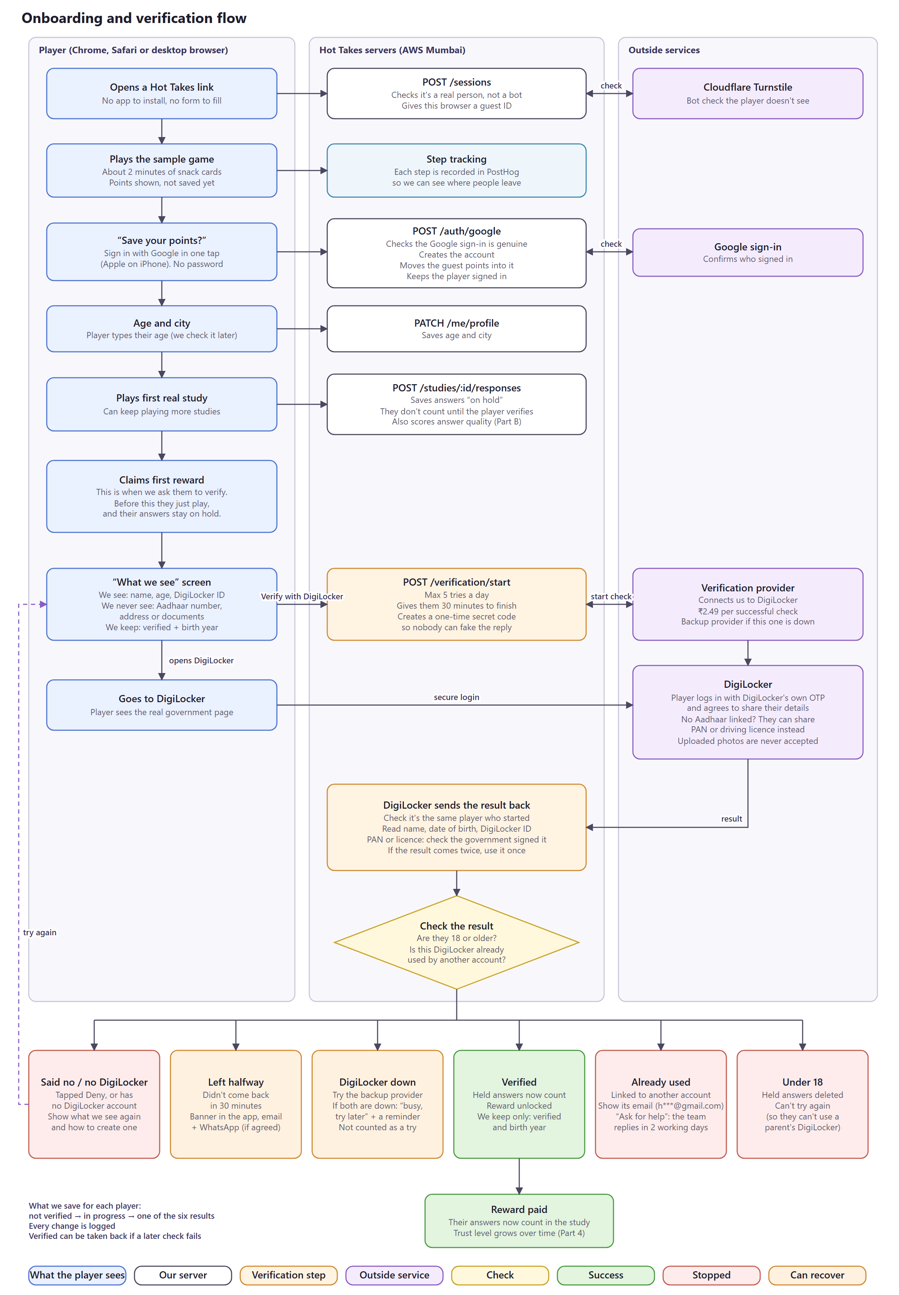
Onboarding and verification flow (editable: challenge2-onboarding-flow.drawio)

3. Recommended technical architecture
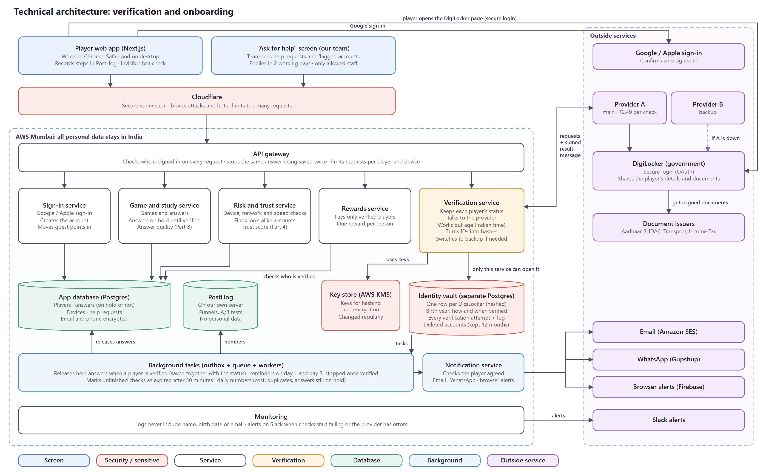
Technical architecture (editable: challenge2-architecture.drawio)
Main choices: the browser never decides anything, only the server does. Verification is its own service with its own locked database, and it's the only part of the system that can read identity data. We talk to DigiLocker through an aggregator behind our own adapter, with a second aggregator ready if the first fails. Everything that has to happen after a status change, like releasing held answers or sending reminders, goes through an outbox so it can't be lost. All personal data stays in AWS Mumbai.

4. Key APIs, backend logic and database considerations
APIs
Endpoint | Called by | What it does
/sessions POST | Browser | Starts an anonymous session, verifies the Turnstile token, stores a fingerprint hash
/auth/google POST | Browser | Verifies the Google ID token (signature with cached keys, audience, expiry), finds or creates the user by Google “sub”, links the anonymous ID, sets a signed HttpOnly, SameSite cookie
/me/profile PATCH | Browser | Saves typed age and city
/studies/:id/responses POST | Browser | Saves an answer with hold_state = held, or released if already verified. Needs an Idempotency-Key header so retries don't double-save
/me/verification GET | Browser | Current status, reason and tries left, which drives the banner
/verification/start POST | Browser | Checks the 5-a-day limit, creates a session (state, PKCE verifier, 30-minute expiry), calls provider.start() and returns the redirect URL
/verification/callback GET | DigiLocker redirect | Checks state against the session cookie, calls provider.getResult(), runs the decision logic below, redirects to the result screen
/webhooks/verification/:provider POST | Aggregator | Checks HMAC signature, timestamp (±5 min) and IP allow-list, then runs the same decision logic. Safe to receive twice
/support/cases POST | Browser | “Ask for help”, for example a disputed duplicate
/admin/review/:caseId POST | Team (Ask for help) | The team decides an “Ask for help” case. Access is time-limited and every action is logged
/me DELETE | Browser | Deletes the account; the DigiLocker hash moves to tombstones for 12 months

Provider adapter
All verification code talks to one interface, so switching aggregators or going direct to DigiLocker later means writing one new adapter:
interface VerificationProvider {
name: 'aggregatorA' | 'aggregatorB' | 'digilockerDirect';
start(s: { sessionId: string; state: string; codeChallenge: string;
redirectUri: string; scopes: ('profile' | 'issued_doc')[] }): Promise<{ redirectUrl: string }>;
getResult(r: { code: string; codeVerifier: string }): Promise<VerifiedClaims>;
parseWebhook(raw: Buffer, headers: Headers): WebhookEvent; // throws if the signature is bad
}
type VerifiedClaims = {
digilockerId: string; dob: string; eaadhaar: boolean;
issuedDoc?: { type: 'PAN' | 'DL'; number: string; dob: string; signatureValid: boolean };
};
A circuit breaker wraps each provider. It opens when more than 20% of calls fail within a minute (with at least 20 calls), sends traffic to the fallback, and tries the main provider again after 60 seconds.
Decision logic (callback and webhook share it)
handleResult(sessionId, claims):
BEGIN
s = SELECT * FROM verification_sessions WHERE id = $1 FOR UPDATE
IF s.status <> 'pending' THEN COMMIT; RETURN -- already handled: idempotent
dob = claims.eaadhaar ? claims.dob
: claims.issuedDoc?.signatureValid ? claims.issuedDoc.dob : NULL
IF dob IS NULL -> transition(s, 'failed', 'no_trusted_doc')
ELSIF ageIST(dob) < 18 -> transition(s, 'under_age'); lock user; outbox('delete_held')
ELSE
dl = hmac(key_v, claims.digilockerId)
doc = claims.issuedDoc ? hmac(key_v, type || number) : NULL
INSERT INTO identities (...) VALUES (...) -- unique indexes do the duplicate check
ON unique_violation -> transition(s, 'duplicate'); open review case
transition(s, 'verified'); outbox('release_held', user_id)
COMMIT
-- claims are dropped from memory here; nothing raw is logged or stored

ageIST(dob): today in Asia/Kolkata; years = today.year - dob.year
minus 1 if this year's birthday hasn't come yet
year-only dates are treated as 31 December of that year
Status transitions
From | To | When
unverified | pending | POST /verification/start
pending | verified | Adult, trusted birth date, identity not seen before
pending | failed (reason) | user_denied, no_account, no_trusted_doc
pending | expired | Expiry job: still pending after 30 minutes
pending | under_age | Under 18. Final, no retry
pending | duplicate → review | Unique index violation on digilocker_hmac or doc_hmac
failed / expired | pending | Player retries (within 5 a day per account and device)
review | verified / failed | Team decision, logged
verified | revoked | A later re-check returns a different identity, or fraud is confirmed

Every transition goes through one function that checks the move is allowed, bumps a version number (so two updates can't clash) and writes a row to verification_events. provider_error is not a status; the session stays pending while we fail over.
Database
Two Postgres databases. The identity vault belongs to the verification service alone; the rest of the app can only ask whether a user is verified and their age band.
-- IDENTITY VAULT (only the verification service's DB role can connect)
CREATE TABLE identities (
identity_id uuid PRIMARY KEY,
user_id uuid NOT NULL UNIQUE,
digilocker_hmac bytea NOT NULL,
doc_type text, -- 'PAN' | 'DL', only on the non-Aadhaar route
doc_hmac bytea,
name_dob_hmac bytea, -- soft match, flags only
birth_year smallint NOT NULL,
method text NOT NULL CHECK (method IN ('eaadhaar','pan','dl')),
key_version smallint NOT NULL,
verified_at timestamptz NOT NULL
);
CREATE UNIQUE INDEX ON identities (digilocker_hmac);
CREATE UNIQUE INDEX ON identities (doc_type, doc_hmac) WHERE doc_hmac IS NOT NULL;
CREATE INDEX ON identities (name_dob_hmac);

CREATE TABLE verification_sessions (
id uuid PRIMARY KEY, user_id uuid NOT NULL, provider text NOT NULL,
state_hash bytea NOT NULL, pkce_verifier_enc bytea NOT NULL,
status text NOT NULL, reason text, attempts_today smallint,
version int NOT NULL DEFAULT 0,
created_at timestamptz NOT NULL, expires_at timestamptz NOT NULL, completed_at timestamptz
);
CREATE INDEX ON verification_sessions (status, expires_at); -- expiry job
-- verification_events: append-only, partitioned by month
-- tombstones (digilocker_hmac, expires_at)
-- outbox (id bigserial, topic, payload jsonb, created_at, processed_at)

-- APP DATABASE
ALTER TABLE responses ADD COLUMN hold_state text NOT NULL DEFAULT 'held'
CHECK (hold_state IN ('held','released','deleted'));
CREATE INDEX ON responses (user_id) WHERE hold_state = 'held';
- Why HMAC: the key lives in KMS, not the database, so a leaked database can't be matched against any other list. Each row records key_version, so the key can be rotated; during a rotation, lookups check both versions.
- Why the database enforces duplicates: the unique index means two sign-ups with the same identity at the same moment can't both get through, whatever the code does.
- What's never stored: full birth date, name, gender, documents and Aadhaar numbers. Email and phone are field-encrypted in the app database.
Background jobs
Job | Runs | What it does
Task runner | All the time | A player's verified status and their answers are in two separate databases, so we can't update both at once. We save a “release answers” task together with the verified status, and this job runs it, again if needed after a crash, so answers never get stuck on hold.
Release held answers | When a player is verified | Answers from real studies the player played before verifying are on hold. Once they're verified, this marks all of them as counted, so they become part of the study.
Expiry | Every 5 min | Pending sessions past expires_at: asks the provider for the result once, then marks them expired
Reminders | Day 1 and day 3 | Email, plus WhatsApp if opted in. Cancelled the moment the player verifies
Retention | Nightly | Deletes sessions older than 90 days, held answers older than 90 days, and expired tombstones
Metrics | Daily | Pushes check costs, duplicates and unreleased answers to PostHog

5. Potential failure scenarios and how I'd handle them
The player-side cases are also in my Challenge 2 notes (sections 2 and 3). Here they're together with the system and fraud cases.
Scenario | How we spot it | How we handle it
Player side
Leaves DigiLocker midway | No callback or webhook within 30 minutes | expired → banner, email on day 1 and day 3, WhatsApp if opted in. “Continue” starts a fresh session; games and points are safe
Taps Deny | Provider returns access_denied | failed (user_denied) → show again what we see, retry any time
No DigiLocker, or no trusted document | Reason code | Short setup guide, then the same reminders
Under 18 | Server age calculation | under_age, final. Held answers deleted, account locked from verifying again
Identity already linked | Unique index violation | Show the masked email of that account; “Ask for help” goes to review within 2 working days
System side
Aggregator down or slow | Error rate and timeouts trip the circuit breaker | Switch to the fallback aggregator. Not counted as a try. Slack alert
DigiLocker itself down | Both aggregators fail the same way | Player sees “DigiLocker is busy”, reminders take over
Callback never arrives (tab closed) | Session still pending | The webhook completes it. If neither arrives, the expiry job asks the provider once before marking it expired
Callback and webhook both arrive | Same session ID | Row lock + status check: the second one does nothing
Same identity on two accounts at once | Unique index | One insert wins, the other becomes duplicate
Token swap fails | Error on the code exchange | Codes work once, so no blind retry. Restart the flow, not counted as a try
Forged or replayed callback / webhook | State mismatch, bad HMAC, old timestamp, unknown IP | Rejected and logged as a security event
Tampered issued document | Issuer signature check fails | signature_invalid → review
Worker crashes while releasing answers | Outbox row not processed | Retried automatically. The release update is idempotent
HMAC key exposed | Incident or scheduled rotation | New key_version, lookups check both during rotation, old key retired
Fraud side
Using a family member's DigiLocker | name_dob match, shared device, look-alike behaviour | Review. A re-check must return the same identity
Many Google accounts | Fingerprint and IP clusters, sign-up bursts | Worthless without a real DigiLocker each. Rate limits and review
Verified account sold or taken over | New device + payout change before a reward | Fresh DigiLocker check that must match the stored hash
Honest family flagged | High false-alarm rate in review results | Flags never block. Loosen the device rule
Data
Database breach | Anomaly alerts | The vault holds only hashes and birth years. Breach plan: notify the Data Protection Board and users
Held answers never released | Older than 90 days | Deleted, and tracked as a metric

6. Metrics I'd track to measure success
Already covered in section 5 of my Challenge 2 notes: 15 metrics across signup, verification, drop-offs, duplicates and time to first participation, tracked with PostHog events and reviewed weekly.

